Business English Program Needs Analysis

This paper presents a study investigating the perceived Business English Program needs of students at a vocational college in Eastern China as parts of a curriculum review and teaching planning revise at the initial stage of program study. The survey is employed the online questionnaire and the data is collected from the 30 respondents. SPSS Statistics is used for statistical analysis. The findings shows that students need work-related language skills and instruction to achieve their goals which is a litter different from the previous plan language learning focused on both academic and vocational setting.

Key words: needs analysis, questionnaire, two step cluster analysis.

Needs Analysis for Teaching Practice

Curriculum refers to the lessons and academic content taught in a specific course or program, which includes learning objectives expected to meet. In many cases, teachers refine and improve them to structure organize and deliver courses in ways that facilitate or accelerate student learning. The revise is based on the analysis of students’ needs for the program. The analysis examines what the learners know already and what they need to know (I.S.P. Nation & John Macalister, 2010). The investigation helps teachers to know learners’ needs so that they could offer effective classroom delivery and assist student to archive their goals.

Hutchinson and Waters(1987) divide language learners’ needs into three parts.
Necessities: what the learner has to know in order to function effectively in the target situation.
- Lacks: what the learner knows already, which of the necessities the learner lacks. The gap between the two can be referred to as the learner’s lacks.
- Wants: what the learners’ want or feel they need.( subjective needs).
- Learning strategies: the learner’s preferred learning strategies for progressing from where they are (present situation / lacks / deficiencies)to where they want to go (target situation / necessities).

Fundamental questions in needs analysis are directed mainly at the goals and content of a course. It examines what the learners know already and what they need to know.
In the book of Language Curriculum Design , I.S.P.Nation and John Macalister (2010) state the result of analysis aim at answering three questions: what the language needs of learners are, in a context, what type of “ English” should be taught and if the curriculum appreciate or make adjudge for leaners.

The Purpose of the Study

The aims of the present investigation examines the perceived Business English language program needs of students at a vocational college in Eastern China. When teachers prepare teaching plans before the beginning of semester, they usually have less information about learners. The students are from different provinces or regions where the quality of education are varied. And even in the same provinces, urban and rural area are also unlike. For this reason, the language levels among the students are distinct. In addition, the learning strategy of work-related language skill at the college is different from general English learning style at school. Therefore, the most students need certain support to facilitate the program study, specially at the beginning of the first term. In order to help the students learn better, we carried out a survey to gain their needs information. The following questions are considered for the investigation: What are the language needs of learners at the initial stage? In a context of business English class setting, what type of “ English” should be taught? If the curriculum appreciate or make adjudge ?

Methodology

The framework of Needs analysis survey is based on the theory of the following researchers study. (West 1994) (Berwick, 1989) (Richtards,2001). There are several ways to investigate. One of these is a survey based on questionnaires. According Richards(2001,86) and Wozniak (2010) on needs analysis survey theory, we design the questionnaire.

According the concept of dimensionality, the test design is used the patten of multidimensional test with uncorrelated dimensions. There are four attributes, each one affecting responses to a set of questions. The attributes are not linked together. Therefore, no total test score is computed. The data analysis is done with SPSS.

1. Questionnaire and data collecting
The questionnaire comprises 39 questions and is composed of four uncorrelated dimensions: personal background items 1-6, language wants items 7-15, language needs items 16-34, learning strategy and class behaviour items 35-39. The thirty students, from two programs responded the questionnaire online. (see the table 1).

Data Analysis

There are three steps.
First, we employed descriptive statistics analysis to examine student personal information and the language wants. We got the background information of each student from item 1-6. Table 1 presents the summary of the information.

Table 1 Participants information ( number: students)
___________________________________________________________________________
Participant 30
Gender Male Female
8 22
Student in Program International Trading Applied English
10 20
Years of learning English 7years Over 7 years
12 18
Regions From Rural Town City
6 18 6
_________________________________________________________________________________________________________________

The following step we want to know that in a context of classroom, what type of “ English” should be taught, general English or academic English or work-related English? The frequency tables for Item 12, 14 reports the student numbers and percentages of respondents.
Table 2 Item 12 and Item14 Frequency Table

________________________________________________________________________________________________________________
Item Not at all useful Not so useful Slightly useful A little useful Somewhat useful Very useful Total
__________________________________________________________________________________________________
12. How useful do you feel work-related 0 0 0 3 (10%) 10 (33.3%) 17(56.7%) 30 (100%)
English instruction is for your future
English language needs?
_________________________________________________________________________________________________________________
Item Academic English Work-related English General English Total
_________________________________________________________________________________________________________________
14. If you could only choose one of the 4 (13.3%) 26 (86.7%) 0 30 (100%)
following types of English instruction,
which would you want to take?
_________________________________________________________________________________________________________________

From Table 2, we can see that almost all students agree that business English instruction is useful for their future development. More than four fifth students consider work-related English study is priority than academic and general English study in the program. In Table 3, we can also see that the mean scores of item 12 and item 14 are much higher than others. In contrast, the deviation scores of the two items are lower which indicate the dispersion of the set of data is narrow, in other words, central tendency distance is short ( see Table 3 ). For example, Item 14. the deviation value is lower because the answers only focus on choices 4,5 and 6. There are only four students wish to have further academic English study. All students think general English is less important than the previous two.

Table 3 presents the entire distribution of central tendency from Item 7- 14. The range of are from strongly disagree or not all useful to strongly agree and strongly useful. As you can see,
there are several statistical values are higher than others. Except item 12 and 14 talked above, the mean scores of item 13,item7 and item10 are noticeable. Surprisingly, the mean value of item13 (how useful do you feel general English instruction is for your future English language needs?) is high. All students agree everyday English is useful. However, when they are asked
Table 3 Descriptive Statistics: Language Wants
___________________________________________________________________________
Item N Minimum Maximum Mean Std. Deviation
__________________________________________________________________________________________
7 30 2.00 6.00 4.9333 0.94443
8 30 1.00 6.00 4.1333 1.75643
9 30 1.00 6.00 3.3333 1.78757
10 30 2.00 6.00 4.5000 1.19626
11 30 1.00 6.00 2.7333 1.89251
12 30 4.00 6.00 5.4667 0.68145
13 30 4.00 6.00 5.0000 0.83045
14 30 1.00 2.00 1.8667 0 34575
_________________________________________________________________________________________________________________

to choose only one of three ( academic or work-related or general ), 86.7% of students choose work-related English instruction, 13.3% choose academic instruction. No student choose general English instruction. And both Item 7 and item 10 value indicate that most students think having English language skill can help them to be more competitive in job market after graduating from university.

Then we use correlate analysis to find if there are any association among students’ learning goals, attitude, classroom behaviour and motivation. If there is one, the correlation coefficient values of the variables is used as a reference for teachers to adjust the curriculum and teaching plan. Table 4 presents the correlation matrix based on four variables, with four rows and four columns. The correlation coefficient reflects the direction of the association between two variables. It tells us that there is a positive and strong association between the two variables. A strong positive correlation indicates a consistent tendency for students who have relatively high scores on one variable to have relatively high scores in the other.

Table 4 Correlation Matrix
________________________________________________________________________
Item 10 Item 8 Item 35 Item 36
__________________________________________________________________________________
Item 10 Pearson Correlation 1 .733 .666 .587
Item 8 Pearson Correlation .733 1 .786 .832
Item 35 Pearson Correlation .666 .786 1 .848
Item 36 Pearson Correlation .587 .832 .848 1
__________________________________________________________________________________

In Table 4, we found that there is a strong positive correlation between the students’ learning attitude (item 8) and their future goal of getting a good job which requires English language skills (item10). We also have found a strong association between motivation (item36) with positive learning attitude (item 8) and classroom participation (item 35). A strong positive correlation indicates a consistent tendency for students who have relatively high scores on one variable to have relatively high scores on the other. Students’ goals are decision-making factors to their attitude and behaviour in learning.

And finally, we examined and grouped student’s needs by two-step cluster analysis. The purpose of cluster analysis is to place items into groups to summarize data in order to get the information of organizing respondents into groups where members of the groups share properties and behaviour in common based on group membership. Figure 1 shows the items within a group be similar (or related) to one another and different from (or unrelated to) the items in other groups.


Figure 1
According the cluster comparison table , we divided the students in similar groups according to their existing levels and needs so that we can effectively help students for study, stimulate their enthusiasm, as well as built up the learning confidence.

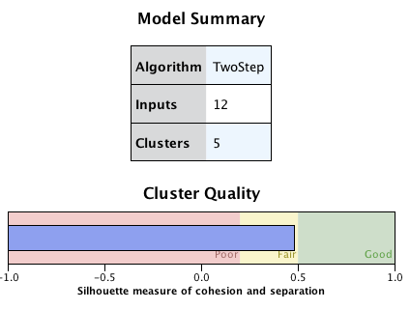
As we can see in Figure 2, we choose twelve items ( continuous variables) in language needs dimension of the questionnaire as input data and fixed five clusters. The Model Summary view indicates that the cluster quality chart indicates that the overall model quality is “fair”.
Figure 2 Model Summary

Regarding the continuous variables importance, we note that the predictor importance is quite positive among the need Items(presentation and discussion:1.00, search information in English:0.81, write course paper: 0.72 and communicating with clients: 0.70). They are listed at the top in each clustered group column.

Figue 3 Predictor Importance
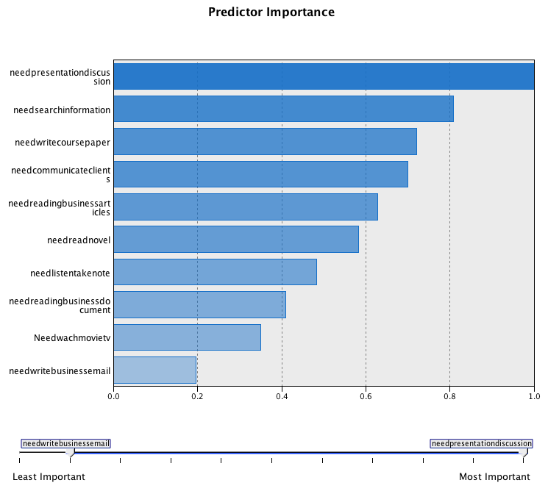
Table 5 shows the cluster distribution. The cluster sizes present the numbers of students and

Table 5 Cluster Comparison TSC_9029
Cluster | 1 | 4 | 5 | 2 | 3
Size | 33.3%  N 10 | 23.3%  N 7 | 20%  N 6 | 13.35  N 4 | 10%  N 3
Inputs | Mean | Mean | Mean | Mean | Mean
Item 28 | 4.00 | 2.00 | 2.33 | 4.00 | 3.00
Item 27 | 4.00 | 1.29 | 1.83 | 3.25 | 2.67
Item 26 | 4.00 | 2.00 | 2.33 | 4.00 | 4.00
Item 32 | 4.00 | 2.86 | 2.67 | 4.00 | 2.00
Item 34 | 4.00 | 1.43 | 1.83 | 2.75 | 3.33
Item 24 | 3.90 | 1.43 | 1.67 | 2.75 | 2.00
Item 29 | 4.00 | 2.43 | 2.83 | 3.25 | 3.00
Item 33 | 4.00 | 1.86 | 2.33 | 3.00 | 3.00
Item 23 | 4.00 | 1.57 | 2.50 | 3.00 | 2.00
Item 30 | 4.00 | 2.29 | 2.67 | 3.50 | 3.33
Item 31 | 3.20 | 2.00 | 2.00 | 2.00 | 2.67
Item 25 | 4.00 | 3.00 | 4.00 | 4.00 | 4.00
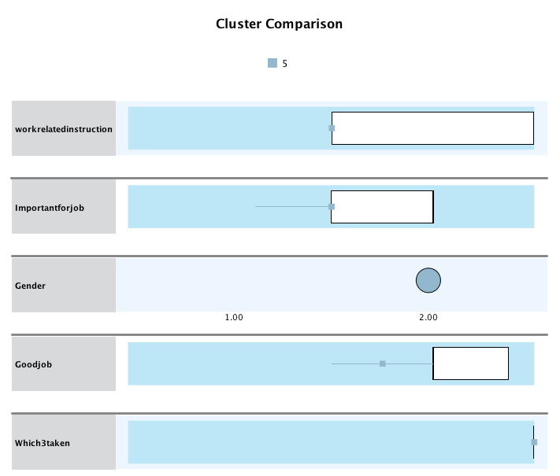
percentages. In the table, the clusters are sorted from left to right by cluster size. The cluster means or the cell distributions suggest that the clusters are well separated. Mean scores in cluster 1 are the highest of the five columns, which account for 33.3% of total student numbers, contains 10 students, which is the largest group and also is the golden group. In this group with high language levels and strong positive learning attitude.
Figure 4 Cluster 5

The most important clusters are column 4 and column 5 because in the two groups mean scores are lower. Figure 4 presents a box plot of cluster 5. In the box plot table, each item in this group presents negative except item 25. This means one third students lack confidence and need more help to improve their existing skills to keep up with the program study. These clustered group data (see Table 6) could help us build up the student profiles to help us monitor their progress. Red figures need special attention.

Table 6 Students’ Profiles
Student | TSC_2993  Cluster Number | TSC_9029  Cluster Number | Student | TSC_2993  Cluster Number | TSC9029  Cluster Number
1 | 1 | 1 | 16 | 3 | 2
2 | 2 | 2 | 17 | 4 | 5
3 | 2 | 2 | 18 | 5 | 4
4 | 4 | 5 | 19 | 5 | 5
5 | 4 | 5 | 20 | 2 | 3
6 | 4 | 4 | 21 | 1 | 1
7 | 4 | 5 | 22 | 1 | 1
8 | 4 | 4 | 23 | 5 | 4
9 | 1 | 1 | 24 | 2 | 3
10 | 1 | 1 | 25 | 5 | 4
11 | 2 | 3 | 26 | 1 | 1
12 | 4 | 5 | 27 | 3 | 1
13 | 4 | 4 | 28 | 2 | 2
14 | 1 | 1 | 29 | 5 | 4
15 | 1 | 1 | 30 | 3 | 1

Discussion and implication

In the first step and second step analysis we found that students need work-related language skills and instruction. And their leaning attitude and behaviour are decided by their present and future goals. In a context of task-based classroom learning setting, work-related English language skills should be taught to achieve the student’s goals.

On the other hand, we have found that the there are some different between the students’ need and the teacher-perceived and program-perceived needs. Therefor, the curriculum and the teaching plan should be make adjudge to meet the learner’s demands.

The assessment has evaluated the student’s real level of English and has a positive effect on teaching practice. Compared with other observations, the result of the test is reliable and valid. We reference the findings to chose right teaching strategies for our expected outcomes.

References

Brown, D. (1983). Conversational cloze tests and conversational ability. ELT Journal, 37(2), 158-161. doi:10.1093/elt/37.2.158
Encyclopedia of research design (2010). In Salkind N. J. (Ed.), . Thousand Oaks, Calif.: SAGE Publications.
Furr, R. M. (2011). Scale construction and psychometrics for social and personality psychology. London: SAGE.
Hutchinson, T. (1987). In Waters A. (Ed.), English for specific purposes : A learning-centred approach. Cambridge [Cambridgeshire]: Cambridge University Press.
Kline, T. (2005). Psychological testing : A practical approach to design and evaluation. Thousand Oaks, Calif.: Sage Publications.
Nation, I. S. P. (2010). In Macalister J. (Ed.), Language curriculum design. London: Routledge.
Review of ELT. (1991).
Richard West (1994). Needs analysis in language teaching. Language Teaching, 27, pp 1-19. doi:10.1017/S0261444800007527.
Richards, J. (1984). Language curriculum development. RELC Journal, 15(1), 1-29. doi:10.1177/003368828401500101
Wozniak, S. (2010). Language needs analysis from a perspective of international professional mobility: The case of french mountain guides. English for Specific Purposes, 29(4), 243-252. doi:10.1016/j.esp.2010.06.001

